**New Live Album *Live at The Whisky a Go Go***

**Out Now -** [**PRESS HERE**](https://sunsetblvdrecords.ffm.to/everclear) **To Listen**

**Releases New Single “Sing Away”**

**With Emotional Music Video**

**Ahead of National Suicide Prevention Week**

[**PRESS HERE**](https://youtu.be/4vWGr89qzu0) **To Watch**

**Fall Headlining Tour Underway Now**

Photo Credit: Ashley Osborn

“Three decades into a career littered with enough hits to fill any set, [Everclear] refuses to let time define them…They quickly prove themselves to be masters of their craft.” – ***Substream Magazine***

“[Everclear] were not just entertaining, they for sure had the energy of a rock band that’s much younger, or maybe just one that is still enjoying what they do on a daily basis? They really did come out embodying everything we love about rock & roll…they are just a raw, talented, fun rock band that is definitely worth the time going out to.” ***– Loud & Heavy***

“The energy Everclear brings is still stratospheric…Everclear is fun, high energy, great music, any night of the week!” – ***Rock At Night***

“After 30 years, Everclear’s passion and energy onstage refuses to diminish.” – ***Dead Noise***

“Each song [on *Live at The Whisky a Go Go*] showcases the band’s aggressive and diverse playing style coupled with Art’s powerful vocals. The excitement in the room was palpable for this fierce and energetic show.”

– ***My Global Mind***

“[*Live at The Whisky a Go Go*] is a loud ‘rough around the edges’ live album…and it fully captures the raw energy the band has pushed over a 30-year career.” – ***Digital Beat Magazine***

“Everclear are one of the most renowned alternative rock bands of the past three decades.” – ***Rock and Roll Globe***

**Los Angeles, CA – September 8, 2023 –** Today, **Everclear**, one of the leading alternative rock bands to emerge from the ‘90s led by vocalist, guitarist and founder **Art Alexakis,** has released their new live album, ***Live at The Whisky a Go Go****,* via **Sunset Blvd Records**. [**PRESS HERE**](https://sunsetblvdrecords.ffm.to/everclear) **to listen**. In addition to the live show, the **17-track** **collection** includes two bonus studio tracks including their new single **“Sing Away**,**”** a powerful song addressing teen suicide and bullying written from the perspective of a grieving parent. Ahead of **National Suicide Prevention** **Week**, which begins this Sunday, September 10th, **Everclear** has released an emotional music video for **“Sing Away**,**”** directed by Brian Cox a.k.a. CiRCUS HEaD. [**PRESS HERE**](https://youtu.be/4vWGr89qzu0) **to watch** **the video**, which first premiered with [***PEOPLE***](https://people.com/everclear-sing-away-music-video-art-alexakis-daughter-exclusive-7967176)*,* who called the visual “heartbreaking and raw” and noted the song “speaks of the importance of allowing music to put a salve on the pain.”

“I had heard about this little boy who had a colostomy bag because of issues that he had been born with, and he had gotten bullied so bad that he went home and killed himself. I mean, he was 10 years old,” **Alexakis** shared with *PEOPLE* about one of the many stories that inspired him to write the song. “As a parent, I don’t see how you go on living. I really don’t know how you go on.” He added, “When it came time to put out this live record, I wanted to record ‘Sing Away’ with Everclear because it has always felt like an Everclear song. I wanted to do it really heavy. And so, we did, and I just love the way it came out.”

To ensure safe messaging around the complex topic of suicide, **Everclear** worked with the **American Foundation for Suicide Prevention (AFSP),** which provided creative guidance on the video for **“Sing Away,”** which concludes with a listing of crisis resources and information on how everyone can play a role in preventing suicide.

**Brett Wean**, the director of writing and entertainment outreach for **AFSP**, commented, “There is nothing more powerful than music in reflecting the feelings so many of us go through. It is so important for artists to spread the message that no one is alone and encourage people to reach out for help when they need it. No one takes their life for a single reason – but bullying can be [one of the risk factors](https://urldefense.proofpoint.com/v2/url?u=https-3A__afsp.org_risk-2Dfactors-2Dprotective-2Dfactors-2Dand-2Dwarning-2Dsigns_&d=DwMFaQ&c=euGZstcaTDllvimEN8b7jXrwqOf-v5A_CdpgnVfiiMM&r=ck0TRRUkenRwq0eeAUA-f3xu62CY0nx-cbGIuzcvYWM&m=2Sb6dGqAvp4-0BUveq3lJeRESmmI0Y-jp21N_u_9FcghyxIA7SHnT20ueoyXINmB&s=ewpl5ZhZeZl3Jlv6MP_gzDYfxJJmRRw0fF5T1dz-N5o&e=). Everclear’s heartfelt lyrics creatively echo AFSP’s recent [Talk Away the Dark](https://urldefense.proofpoint.com/v2/url?u=https-3A__afsp.org_talkawaythedark&d=DwMFaQ&c=euGZstcaTDllvimEN8b7jXrwqOf-v5A_CdpgnVfiiMM&r=ck0TRRUkenRwq0eeAUA-f3xu62CY0nx-cbGIuzcvYWM&m=2Sb6dGqAvp4-0BUveq3lJeRESmmI0Y-jp21N_u_9FcghyxIA7SHnT20ueoyXINmB&s=_BRSKca_Sjt-Pa9KvUxK0Ykg6yi200A4uuKHAxSJmEg&e=) campaign: ‘Sing the words that keep you safe.’ We’re so grateful to Art Alexakis and Everclear for raising awareness of this leading cause of death and letting people know [support is available](https://urldefense.proofpoint.com/v2/url?u=https-3A__afsp.org_get-2Dhelp_&d=DwMFaQ&c=euGZstcaTDllvimEN8b7jXrwqOf-v5A_CdpgnVfiiMM&r=ck0TRRUkenRwq0eeAUA-f3xu62CY0nx-cbGIuzcvYWM&m=2Sb6dGqAvp4-0BUveq3lJeRESmmI0Y-jp21N_u_9FcghyxIA7SHnT20ueoyXINmB&s=EhclfsTEmIWuS1ACOMEhwWcKaGFk-bHAlh_KoLu2gl0&e=) for those struggling and for those who have lost someone.”

***Live at The Whisky a Go Go***, available digitally, on CD and 2-LP Coke bottle green vinyl, was recorded and filmed in late 2022 during **Everclear’s 30th** **Anniversary** **Tour** in Alexakis’ hometown of Los Angeles and marked the first time the acclaimed quartet performed at the famed venue. The album features all the hits and hidden treasures from throughout the band’s extraordinary catalog, including **“Father Of Mine,” “Wonderful,” “Santa Monica,”** and **“I Will Buy You A New Life”** as well as last year’s single **“**[**Year Of The Tiger**](https://youtu.be/oJEcgmC_Q10)**”** in addition to **“Sing Away**.**”** [**PRESS HERE**](https://youtu.be/Rj68atiZnDs)to watch the live video from The Whisky for **“Heroin Girl,**” the band’s 1995 hit off their platinum-sellingalbum ***Sparkle and Fade.*** Full track listing for ***Live at The Whisky a Go Go*** below.

**Everclear – Art Alexakis** (vocals, guitar), **Davey French** (guitar), **Freddy Herrera** (bass), **Brian Nolan** (drums) **–**will showcase their incredible live show on the road this fall on a headlining tour that just kicked off this past Wednesday, September 6th. The 30-date outing, featuring special guests **The Ataris** and **The Pink Spiders**, stops all across the country including **New York City (September 18th), Nashville (September 21st)** and **Los Angeles (October 9th)** before wrapping **October 15th**. See below for full list of upcoming tour dates. Tickets are on sale now; visit [www.everclearmusic.com/tour](http://www.everclearmusic.com/tour) for all details and to purchase tickets.

Since forming in 1992, **Everclear** has enjoyed a lengthy career by any measure, spanning 11 studio releases, including four that have been **certified Gold or Platinum**, selling over 6 million records, and achieving **12 Top 40 Hit Singles** on Mainstream Rock, Alternative, and Adult Top 40 radio, including **“Santa Monica,” “Father of Mine,” “I Will Buy You A New Life,” “Wonderful”** and **“Everything To Everyone,”** as well as numerous videos, thousands of shows, and various other accolades, including a 1998 Grammy nomination. The band’s 1993 debut album, ***World Of Noise***, released on the Portland independent label Tim/Kerr Records, paired with their significant efforts to break into college radio and the buzz they’d created within the Portland music scene, attracted the attention of major labels, including Capitol Records, which signed the group soon after. Beginning with their major-label debut, 1995’s platinum-sellingalbum ***Sparkle and Fade***, and its massive chart-topping hit “**Santa Monica**,” **Everclear** was soon a household name and catapulted into the masses, thus allowing their impressive three-decade career to prosper and endure. In 2019, **Alexakis** was diagnosed with multiple sclerosis (MS) and has since donated one dollar from every ticket purchased for his performances to charities such as Sweet Relief Musicians Fund and National MS Society. To celebrate their 30th anniversary in 2022, **Everclear** reissued [***World Of Noise***](https://fanlink.to/everclear) as a special remastered, deluxe edition, making the album available for the first time on digital streaming platforms with 6 bonus songs in addition to its original 12 tracks. In addition to his thousands of Everclear performances over the band’s lengthy career, **Alexakis** created and runs the annual Summerland Tour, which features a package of popular ‘90s alt rock bands, and he released his first solo album, *Sun Songs*, in 2019. [**PRESS HERE**](https://youtu.be/A0habF0qy3o)to watcha special commemorative anniversary video, **“Everclear – 30 Years Gone: A Retrospective,”** hosted by former MTV VJ, current radio host and longtime friend **Matt Pinfield**.

More than three decades in, **Everclear’s** enduring legacy and ongoing appeal as a live band continues.

***LIVE AT THE WHISKY A GO GO* TRACK LISTING**

1. Introduction (by Matt Pinfield)
2. So Much For The Afterglow
3. Everything To Everyone
4. Heroin Girl
5. Heartspark Dollarsign
6. Father Of Mine
7. Nervous and Weird
8. Fire Maple Song
9. Wonderful
10. Strawberry
11. AM Radio
12. Local God
13. I Will Buy You A New Life
14. Santa Monica
15. Molly’s Lips
16. Year Of The Tiger (Bonus Studio Track)
17. Sing Away (Bonus Studio Track)

**EVERCLEAR TOUR DATES**

***Fall Headlining Tour w/ The Ataris and The Pink Spiders supporting:***

Friday, September 8 Lemont, IL @ The Forge Lemont Quarries

Saturday, September 9 Fort Wayne, IN @ Piere’s

Monday, September 11 Cleveland, OH @ House of Blues

Tuesday, September 12 Buffalo, NY @ Town Ballroom

Wednesday, September 13 Silver Spring, MD @ The Fillmore Silver Spring

Friday, September 15 Philadelphia, PA @ Rivers Casino ^

Saturday, September 16 Westbury, NY @ The Space at Westbury

Sunday, September 17 Boston, MA @ Big Night Live

Monday, September 18 New York, NY @ Gramercy Theatre

Wednesday, September 20 Raleigh, NC @ The Ritz

Thursday, September 21 Nashville, TN @ The Sky Deck at Assembly Food Hall

Friday, September 22 Mt. Vernon, IL @ The Granada Theatre

Saturday, September 23 Waterloo, IA @ National Cattle Congress

Sunday, September 24 Minneapolis, MN @ Uptown Theater

Wednesday, September 27 Omaha, NE @ Barnato

Thursday, September 28 Denver, CO @ Gothic Theatre

Friday, September 29 Kamas, UT @ DeJoria Center Arena

Saturday, September 30 Cheyenne, WY @ The Lincoln

Sunday, October 1 Great Falls, MT @ The Newberry

Tuesday, October 3 Bellingham, WA @ The Wild Buffalo +

Wednesday, October 4 Seattle, WA @ The Crocodile

Friday, October 6 Umatilla, OR @ Rock The Locks +

Saturday, October 7 Elko, NV @ Maverick Hotel and Casino by Red Lion Hotels +

Monday, October 9 Los Angeles, CA @ The Wiltern

Tuesday, October 10 San Francisco, CA @ August Hall

Thursday, October 12 Temecula, CA @ South Coast Winery Resort & Spa +

Friday, October 13 Rocklin, CA @ Quarry Park Amphitheater

Saturday, October 14 Las Vegas, NV @ Silverton Casino Hotel

Sunday, October 15 Pioneertown, CA @ Pappy + Harriet’s

Friday, October 27 North Augusta, SC @ Jack-O-Lantern Jubilee +

Saturday, November 4 Tybee Island, GA @ Tybee Post Music Festival +

+ indicates Everclear only

^ indicates Everclear and The Ataris only

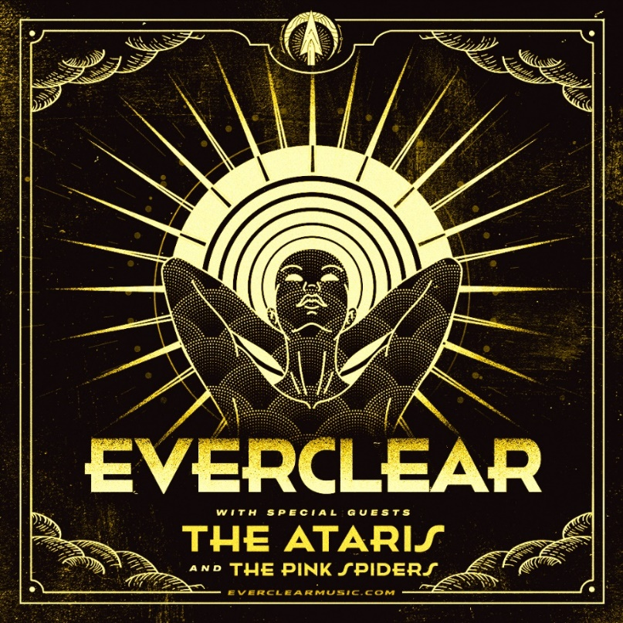

Follow **Everclear**:

[Website](https://www.everclearmusic.com) // [Facebook](https://www.facebook.com/everclear) // [Instagram](https://www.instagram.com/everclear/) // [Twitter](https://twitter.com/EverclearBand) // [YouTube](https://www.youtube.com/channel/UClxjm6JR5j7Wc_uP20OjUCA)// [Spotify](https://open.spotify.com/artist/694QW15WkebjcrWgQHzRYF) // [Apple Music](https://music.apple.com/us/artist/everclear/549623)

For press inquiries**,** please contact:

**Press Here**

Bari Lieberman / [bari@pressherepublicity.com](mailto:bari@pressherepublicity.com)