
Accounting & Information
Management System
PLANNING
(BUDGETING)
Table of Contents

AIMS/SAP Planning

I. Planning in AIMS/SAP

Cost Centers/Cost Center Groups I-1

Fiscal Periods/Years I-2

Plan Versions I-3

Plan Profiles I-3

II. Entering Data

Initial Screen II-1

Default Values II-2

Overview Planning II-3

Period Planning II-3

Distribution Keys II-4

Changing Combinations II-5

Adding Data II-5

Copying Cell Amounts II-7

Revaluation Factors II-8

Lead Column Options II-8

Long Text II-9

III. Planning Reports

Report Trees III-1

NAF Budget Report III-2

Conversion to Excel III-4

IV. Contacts

Contact Information IV-1

Changing Excel Macro Security IV-1

Cost Centers/Cost Center Groups IV-2

Adding Transactions Codes to Favorites IV-2

PLANNING IN
AIMS/SAP

Planning in AIMS/SAP

Planning is the term for Budgeting in SAP. Planning takes on a much different form in SAP than it did in RAMCAS. The purpose of this course is to familiarize you with these changes so you may enter your budget without trepidation. Once you see how the process works and how to review the data, you will see that planning in SAP can enhance your budgeting experience.

Background

Planning in SAP is used for enforcing spending caps within the system and is done for a combination of cost centers and cost elements (RAMCAS accounts). There are four areas one must keep in mind while working in the Planning module. These are:

- Cost Centers/Cost Center Groups
- Fiscal Periods/Years
- Plan Versions
- Planning Profiles

Cost Centers/Cost Center Groups

In SAP, the departments that make up an activity, ie Food Resale, Program Operations, are the Cost Centers for that activity. A Cost Center represents a location where revenue and expense originate. All Planning in SAP occurs at the Cost Center level.

A Cost Centers is a single number that falls in the range 1 – 20000. Cost Centers do not include commas. Ex. 519 or 10306

When you combine together all of the Cost Centers for a particular Activity you get a Cost Center Group which represents the entire activity.

A Cost Center Group consist of the Company Code (a four digit number that resembles the old RAMCAS Fund number) followed by a hyphen and then a another four digit number beginning with either a 4, 5 or 6. Ex. 1034-4011 or 1120-4005.

Your level within the organization determines your responsibilities regarding Cost Centers and Cost Center Groups. For example you may only be responsible for rentals at the Marina or you may be in charge of the entire Marina. It is important that you know which cost centers you are responsible for when planning in SAP. Check with a supervisor if you are not sure.

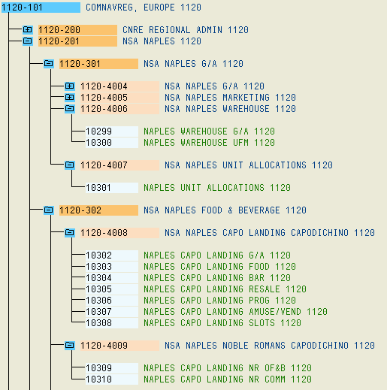
Cost Center Groups
Cost Centers

Fiscal Periods/Years

Plans are entered and saved by fiscal period and fiscal year. Periods must have a beginning period and an ending period. If you are only entering one month, then the beginning period is the same as the ending period.

When entering data you must ensure that you have identified the correct period. For example, if you are entering data for the entire FY, you must enter periods 1 through 12.

If you are entering data for a specific month, April, then you must specify 7 through 7.

You must also be aware of what Fiscal Year you are entering data for. For purposes of this class, you will all be entering data for FY 2008.

The plans can (and will) be locked by CNIC FFSC HQ Mill-Det for each fiscal year to prevent plans from being overwritten and/or entered into the wrong year.

Plan Versions

Plan versions are just what the name implies, different versions or scenarios, of your budget. You may have multiple versions of the same fiscal year but only one will be submitted to CNIC FFSC HQ Mill-Det for approval. The version that is submitted as the ‘final’ budget will be locked in the final months of the current FY so that it cannot be altered but the remaining versions will be left open for you to amend as you see fit.

For FY-08, stations will be asked to enter their budgets into Version 1. Once this data has been modified and approved, it will be copied to Version 0 and locked. This will be your final budget for submission and approval. When entering data, SAP will default automatically to Version 1 and will not respond if it is changed to Version 0. Version 1 will then be left open for you to modify as the year progresses.

Plan Profiles

Plan Profiles are SAP templates used for inputting Plan data. There are currently four different Profiles for you to choose from. Keep in mind that different profiles can be used by different managers and for different cost centers. Use the one that suits you. The profiles are:

- Z-101: AIMS - Current year Plan and Prior year Plan (Displays the specified (upcoming) fiscal year planning data along with the prior year planned data).
- Z-102: AIMS – Current Year Plan Only (Displays only the specified (upcoming) fiscal year).
- Z-103: AIMS – Cur. Yr Plan and Adjusted Prior Yrs Actuals (Displays the specified (upcoming) fiscal year data along with the actual data from the first six months of current year and the last six months of prior year).
- Z-104 : AIMS – Cur. Yr Plan and Prior Yrs Actuals & Plan V1 (Displays the specified (upcoming) fiscal year data along with the actual data from the first six months of current year and the plan data for the last six months of current year).

Following are the initial screens that you will see when entering Plan data into SAP. The first screen is where you select the Profile, the second is where you select Fiscal Year, Version, etc. Section II covers this in more detail including where to locate it.

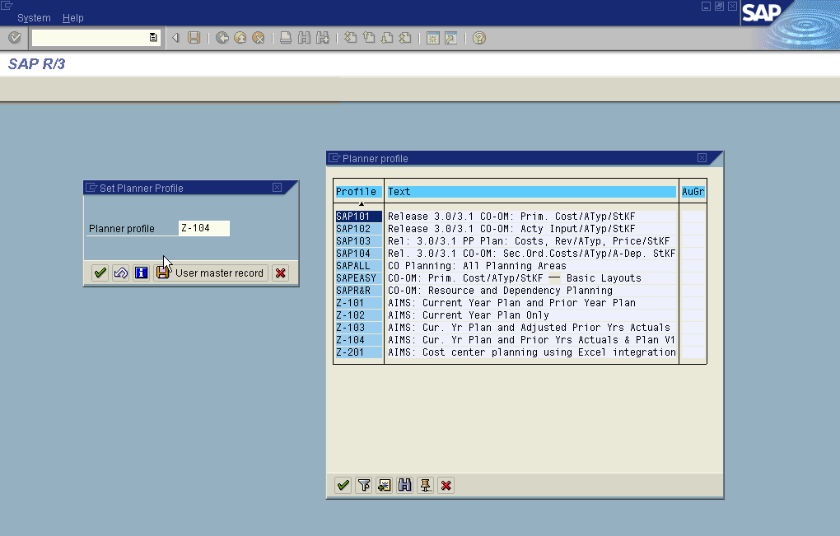

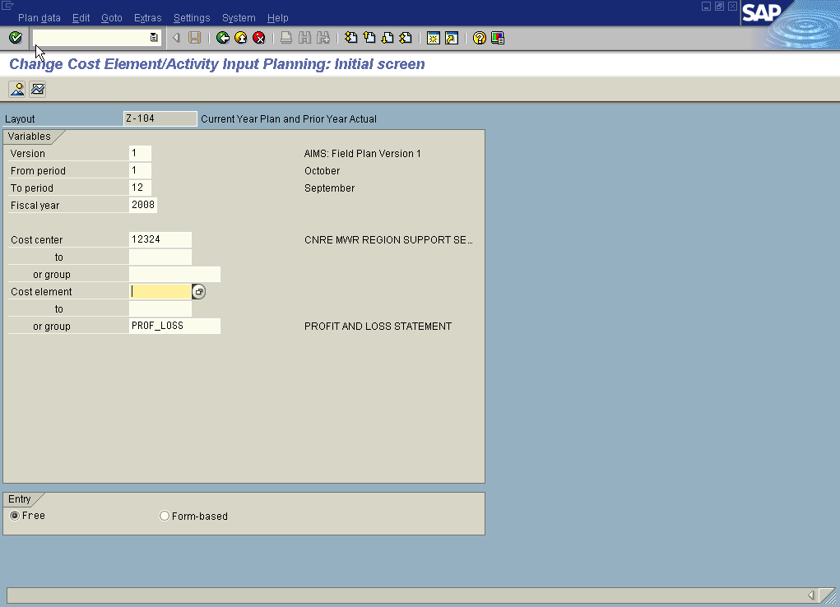
Enter the Cost Center, Cost Center Group or Cost Element for which the plan amounts will be entered on the next screen
Default values appear on the screen
Identifies what profile you are using
Use Settings to change the profile

If you decide to change the profile, you must click on Settings and then Set Planner Profile. You will get a box that displays the current profile, click on the drop down menu to see the other profiles available. Once you have selected one, double click on it and then hit the green check mark.
The four Profiles are as follows:
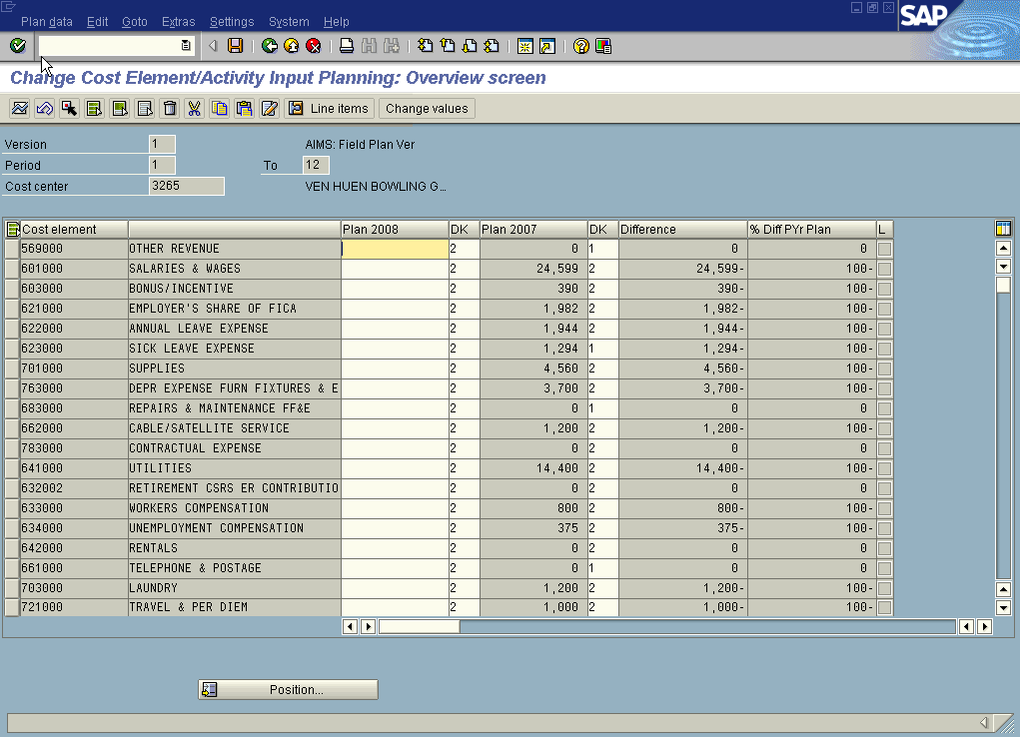
The Z-101 Profile layout

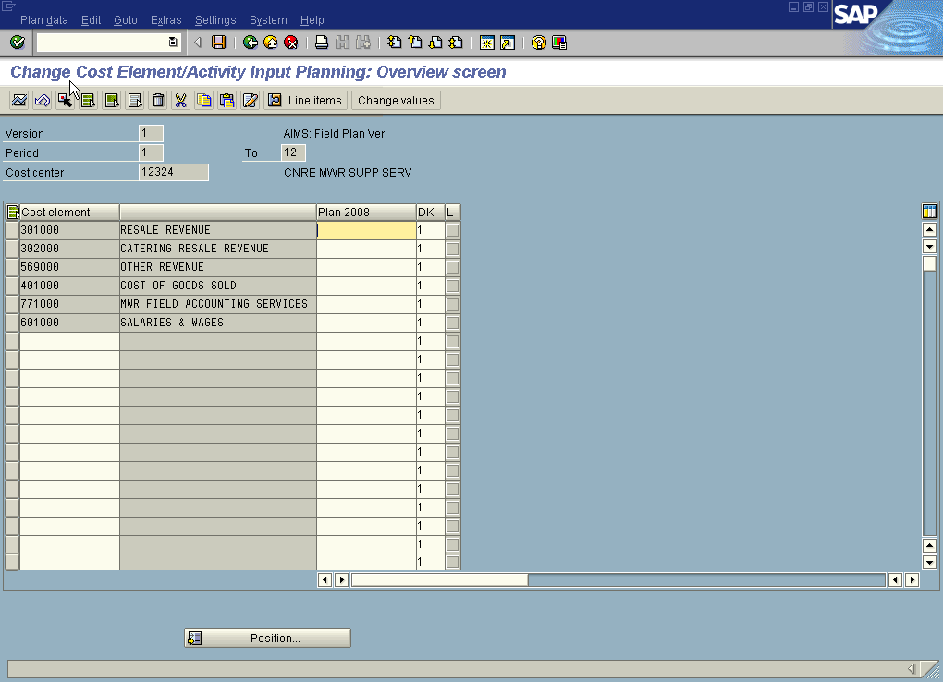
The Z-102 Profile layout
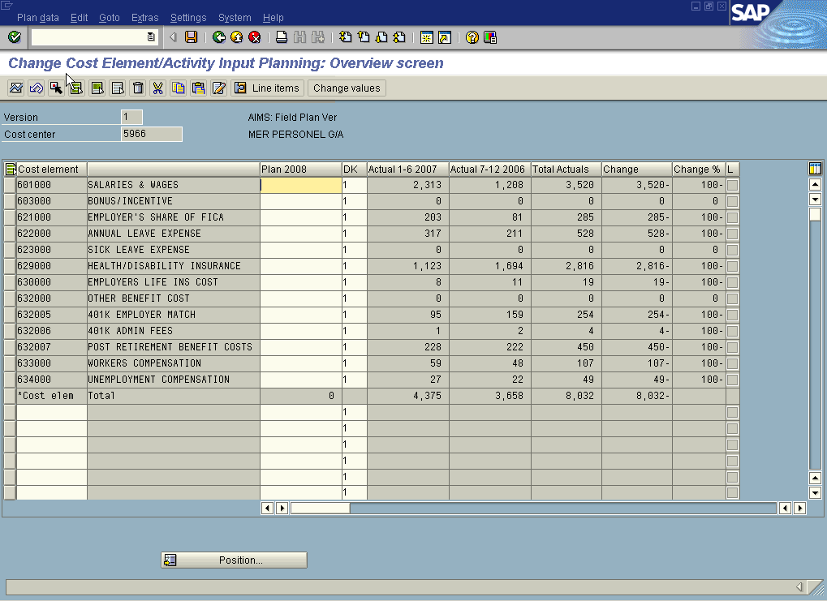
The Z-103 Profile layout

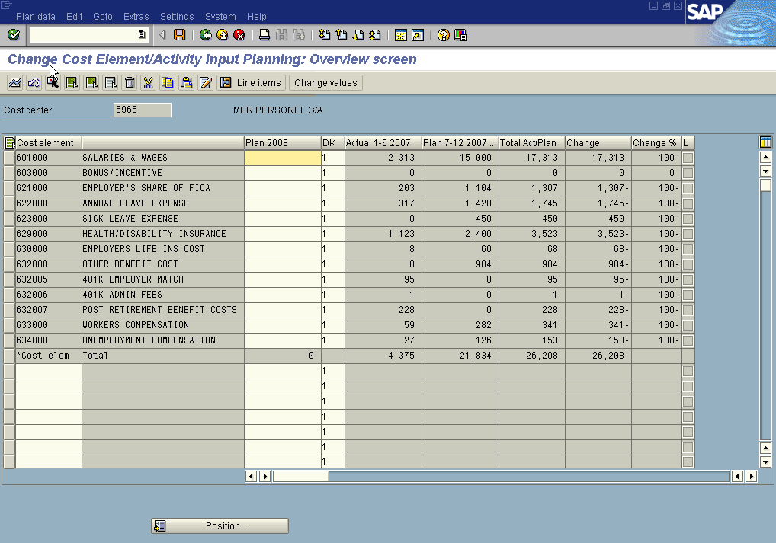
The Z-104 Profile layout

ENTERING
DATA

Entering Data

As you will see, there are several ways of entering data for planning. In this section we will go through the initial entry screen to the actual entries.

Initial Entry Screen

To enter data into a cost center plan you must first get to the right place. The following menu path will get you there:

Accounting → Controlling → Cost Center Accounting → Planning → Cost and Activity Input → Change

An alternative is to use transaction code KP06 Change Cost Element/Activity Input

Hint: To add this transaction code to your favorites simply select Favorites from the
main menu and pick Insert transaction and type in KP06 and then click the green
check mark.

On the initial plan entry screen, enter either a cost center number or a cost center group (refer to your fund hierarchies). The differences between the 2 are as follows:

- Enter a single cost center number to enter plan amounts by cost element for the selected cost center. It is similar to budgeting for one department, ie Food Resale or Program Operations, of a specified activity.
- Enter a cost center group to enter plan amounts by cost element for each cost center in the group. This would be like inputting data for each department of an activity, ie Food Resale, Bar Resale, Program Operations, of the Bowling center.

You will also need to select between Form-Based or Free entry when you are entering in your data. The difference between the two is as follows:

- Free Entry - (Recommended) Only displays accounts where Plan Data currently exists. Free Entry will display fewer account elements on the Overview planning screen but does not prevent different or additional cost elements from being planned for a cost center.
- Form-Based – (First Time) Every Account is displayed. This means that all account elements will be shown whether or not there are plan/actual amounts.

REMINDER: The SAP system, as currently configured, requires that Revenue accounts (3,5,800xxx series) be entered as negatives (with the minus sign at the end, ie 578.25-) and Expense accounts (4,6,7,900xxx series) be entered as positive amounts. The only exception is the UFM accounts (747-759xxx) which need to be input as negatives also. However, the reports have been configured to reverse these signs so that all amounts will appear as positive values.

The initial plan entry screen looks as follows:

Enter the cost center or cost center group for which the plan amounts will be entered on the next screen
Default values appear on the screen
Choose Free Entry Mode to suppress cost elements without dollar amounts on the overview planning screen or Form-Based to display all cost elements

Default Values

The following values are defaulted automatically by the system on the initial plan entry screen:

- Plan Version = 1
- From Fiscal Period = 1
- To Fiscal Period = 12
- Fiscal Year = Budget Year
- Cost Element Group = PROF_LOSS

Once you have selected the fiscal periods, year, version, cost center and method of entry you are ready to start inputting data. SAP gives you two options for entering; Overview and Period.

Overview Planning
The Overview view is for entering annualized planned amounts for a given cost center. This means that you enter in the total year value for each income/expense account.

The Overview screen presents the revenue/cost elements in Income Statement (Profit/Loss) order, before consolidations, as seen on the Executive Summary report.

In this view you can the use a Distribution Key (DK) to allocate that amount over the entire fiscal year. We will speak more about this later.

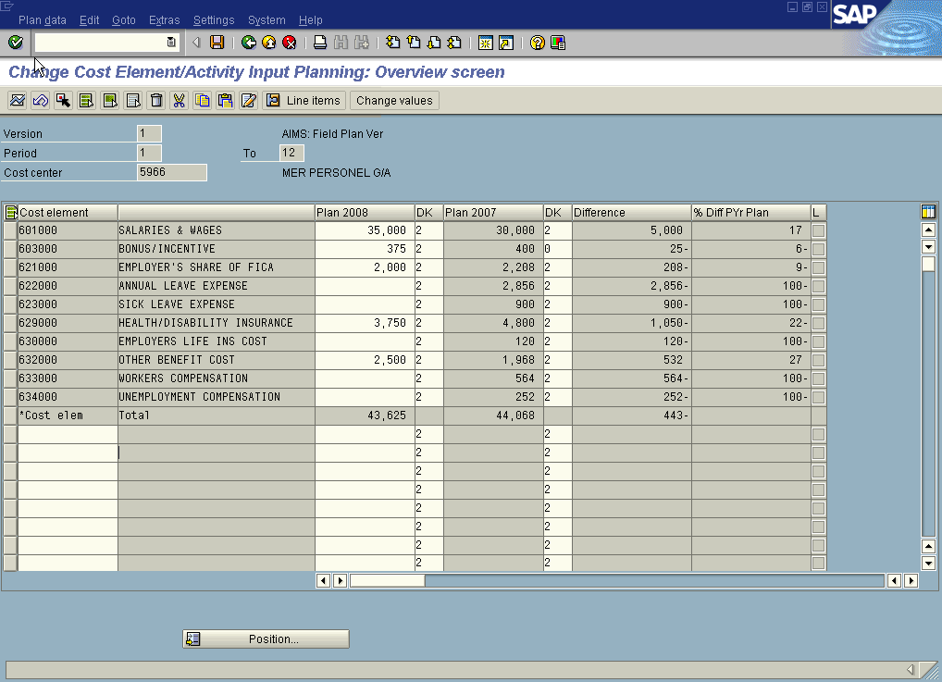
Annualized plan amounts are entered in the overview planning screen
Only cost elements with dollar amounts are shown (Free Entry Mode)
DK – Distribution Key

Period Planning
The Period view is for entering planned amounts on a month by month basis for a given cost element. This lets you tailor specific accounting elements if they do not fit one of the pre-defined Distribution Keys (DK).

The Period view is visually very different from the Overview screen and is a much more methodical way of inputting data.

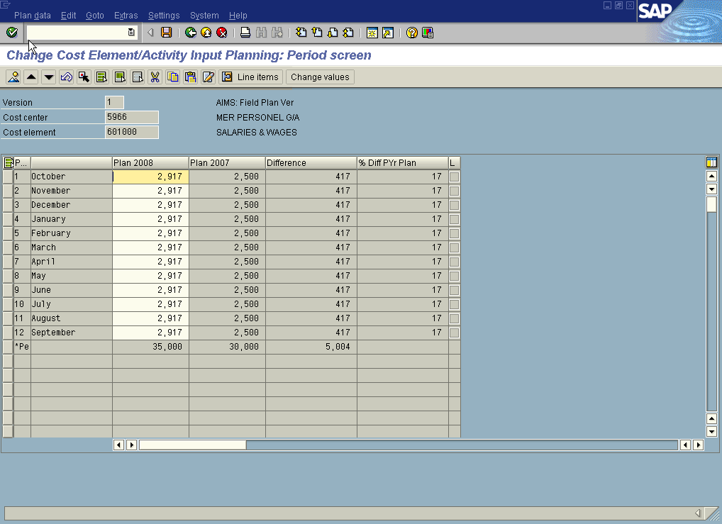
Plan entry by period by cost element
Monthly (period) plan amounts are entered using the period view screen

Using the two views together

Using the two differing views, Period and Overview, can be very useful. To do this, all you have to do is click on the appropriate icon to toggle back and forth.

For instance, assume that you have just entered data in the Overview screen and have chosen a specific distribution key. However, this DK doesn’t distribute the data they way you think it should, so you highlight that amount on the Overview screen and click the Period screen Icon and it will come up in the Period screen. Here you can adjust each month to where it needs to be.

Distribution Keys
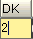
Distribution Keys (DK) are used to automate the Overview planning process. They enable the planning of a cost element using an annualized amount. These amounts can then be ‘distributed’ or allocated across the 12 fiscal periods (months) using various factors. As you can see there are a number of factors to choose from.

To access the Distribution Keys all you have to do is click in the column and go to the drop down menu.
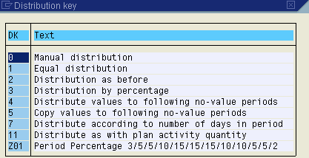

Changing Combinations

In SAP Combinations refers to the remaining cost elements of a cost center, or the remaining cost centers of a cost center group. The process is the same for either scenario:
Goto → Next Combination (or Previous Combination) or use these -→

Adding Data

If you choose to input data using the Free Entry method (only displays cost elements where data currently exists) and you would like to add a cost element that isn’t displayed, you can do it as follows. First you must scroll down to the bottom of the cost elements and click on one of the empty cost element cells.

Scroll down and choose an empty cost element cell
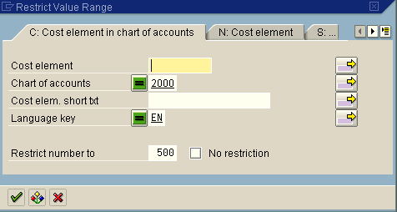
A drop down menu will appear and you will need to click it. The following screen will appear:

If you know the exact cost element you can enter it. If you don’t but have an idea of the range that it is in you can use the asterik * to help you find it. Simply type the first or second digit, ie 7 or 76 and follow it with the asterick and hit the green check. This will bring up every cost element that begins with those numbers.
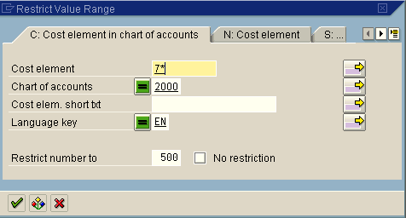

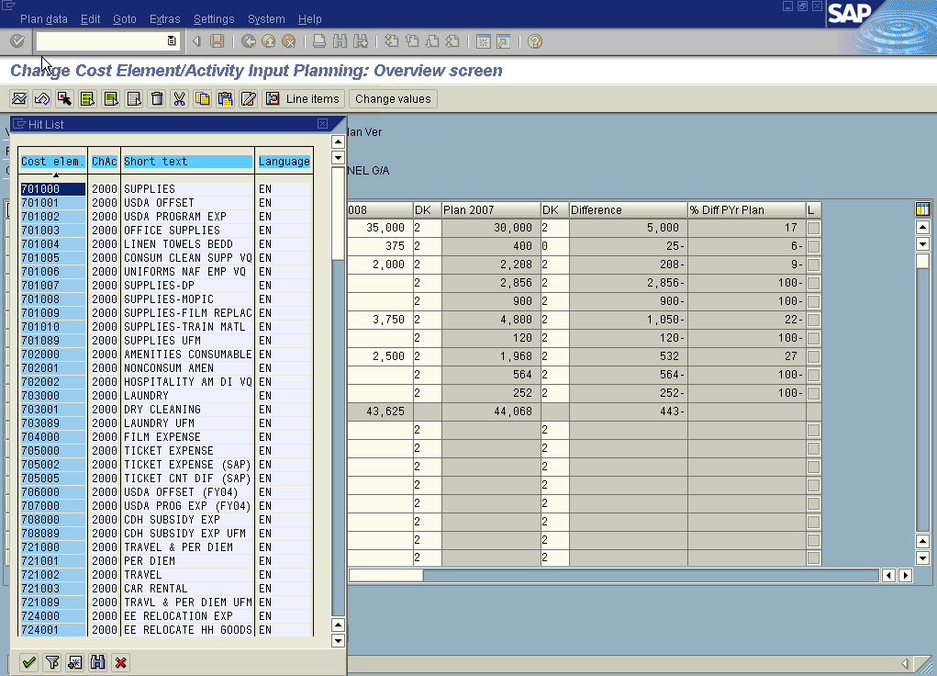
A listing of all Cost elements that you searched on

Once you have selected the appropriate cost element, highlight it and click the green check mark. Enter the data in the corresponding cell and hit enter. The cost element description will show up. The data will remain on the bottom of the screen until you save and exit or toggle over to the period screen. If you do this, the cost element will be in the correct place on the screen when you toggle back.

If you select a cost element that is already taken you will get a message at the bottom of the screen which says ‘the row you entered already exist’. To undo, click the Reset row icon on the second toolbar.

Copying Cell Amounts

To save time, individual or blocks of cells on the planning Overview screen can be selected and copied or moved to other cells.
Use the Select , Select All or Select Block buttons to choose the cells to copy or move. Paste the copied or cut cells by placing the cursor on the desired entry cell and then press the Paste button.

Revaluation Factors
Revaluation Factors are percentages or numerical values that can be applied to plan amounts to raise or lower them a specified amount.

To apply the Revaluation factors, first you must highlight the desired cell or cells and then click on the Change Values button. Select either Percentage or value depending on what you prefer. If you want to raise/lower the amount by a fixed percentage, type the percentage amount in and click the Revaluate button. If you want to change the amount by a fixed amount, type it in the Value area and click the Add Values button.

Remember that if you want to lower the data, precede your change with a negative sign.

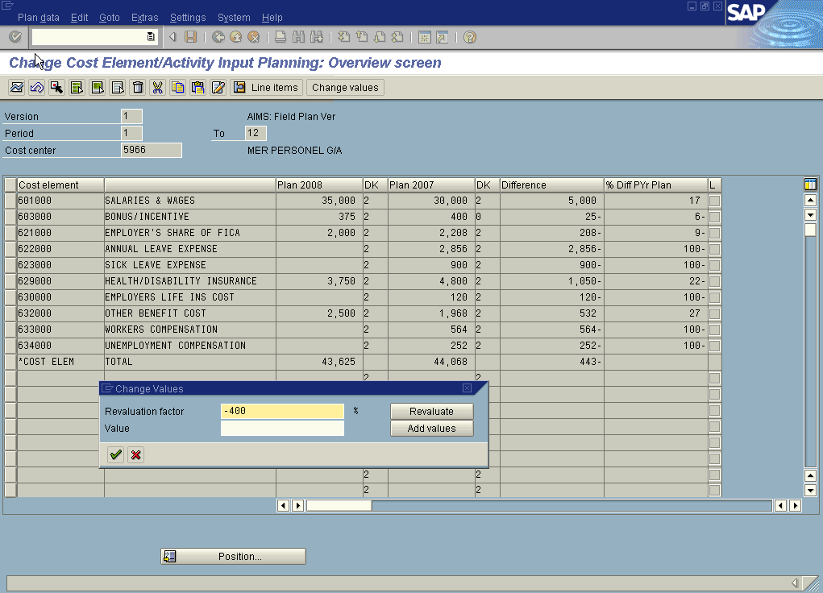

Lead Column Options

Within the Overview screen, the lead column (accounting element) can be displayed with the accounting element hierarchy node subtotals.

Settings → Lead Column
Select either Hierarchy or Total or No Total
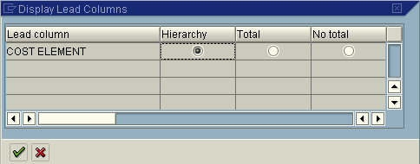

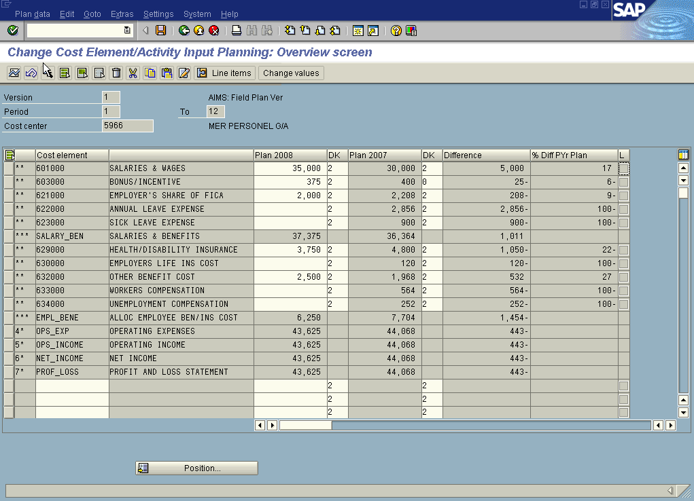
Notice new sub-totals

Long Texts

Detailed long texts can be attached to each plan amount for an individual accounting element. This is where you can store the backup (method or reason) for a particular number for future reference.

To do so, highlight the desired plan amount cell, and press the Long Text button. Enter as much text as you like. Be sure and save the text by pressing the save icon.

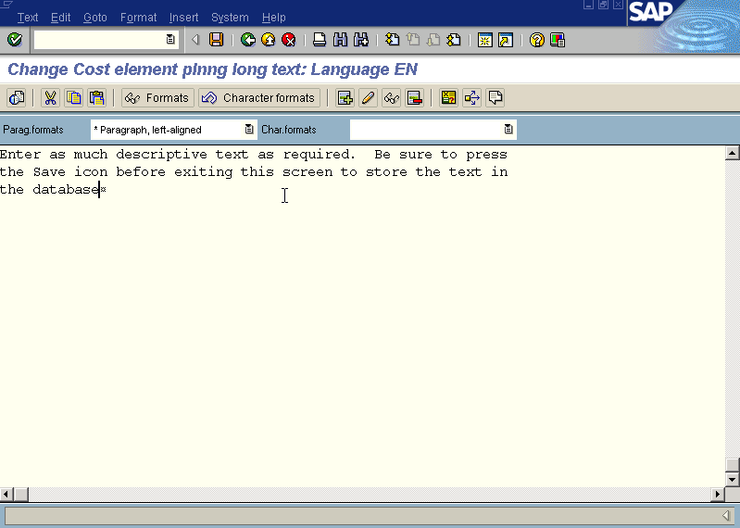

PLANNING REPORTS

Planning Reports

There are many reports within SAP that display plan along with actual data. For Planning purposes you will most likely use the Budgeting Reports found on the Report Tree

Report Trees

Cost Center Account:

Accounting → Controlling → Cost Center Accounting → Information Systems → Report Selection

An alternative is to use transaction code KSBB Application Tree Report Selection

Hint: To add this transaction code to your favorites simply select Favorites from the
main menu and pick Insert transaction and type in KSBB and then click the green
check mark.

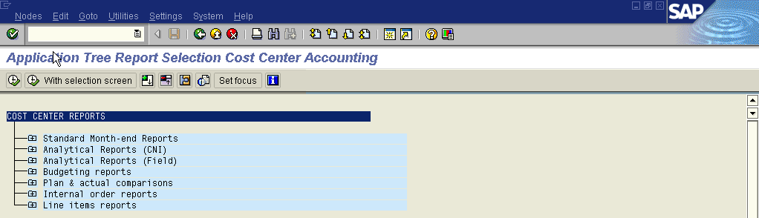
Planning Reports

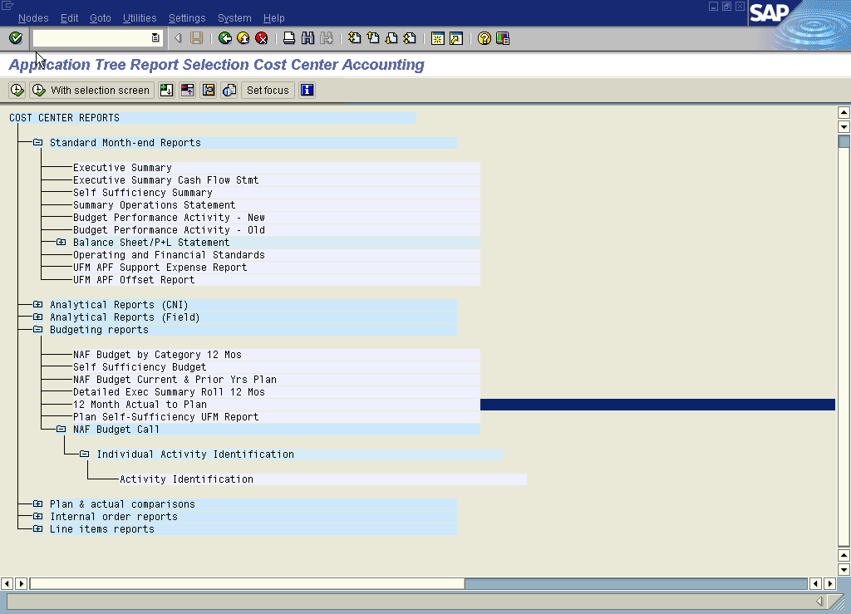
Reports you will use when Planning

NAF Budgeting Reports

SAP has been set up to provide a report that is very similar to the Fund Summary (TAB D) of the NAF Budget package that you receive in Excel. This report can also be used to provide you with the Cat A,B,C Summaries (TAB C).

This is the report that will help you input your data into the Excel package so that it can be loaded into RAMCAS.

This report will automatically default to the current fiscal year so you will need to change it to the upcoming budget year.

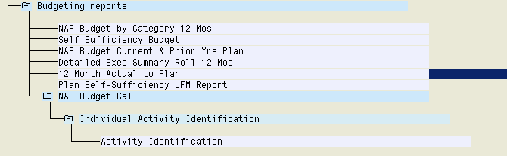
This report is very similar to the Excel report you have used for years
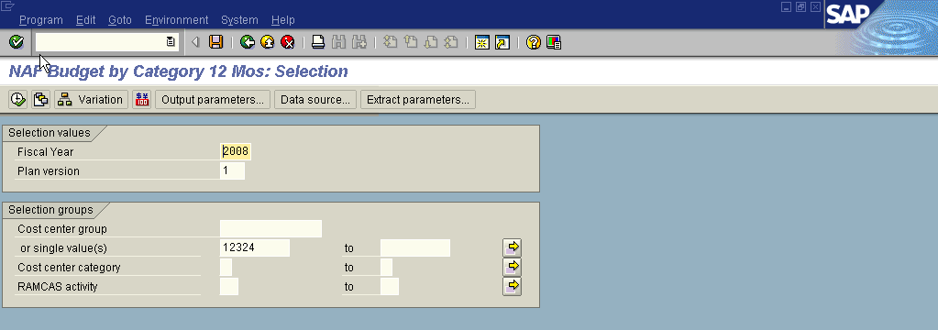
You can also use this report to provide you with an individual activity if you know the RAMCAS activity number (22 – CDC)

The fiscal year, fiscal periods and plan version parameters on all reports will determine which plan data is displayed.

Plan version ‘0’ is the default value on all plan/actual reports in the system so you will need to change this to Version 1 while in the process of Planning to see any results.

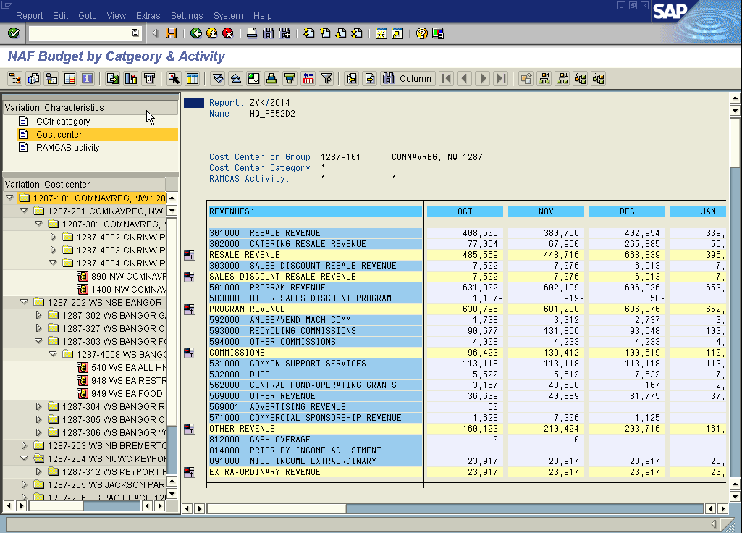
Toggle back and forth using the navigation icon to display additional report info
Click on these to expand or contract the amount of data shown

Depending on the level of data that you are requesting, Cost Center group and up, you can use the Navigation icon to hide all the drill down capabilities.
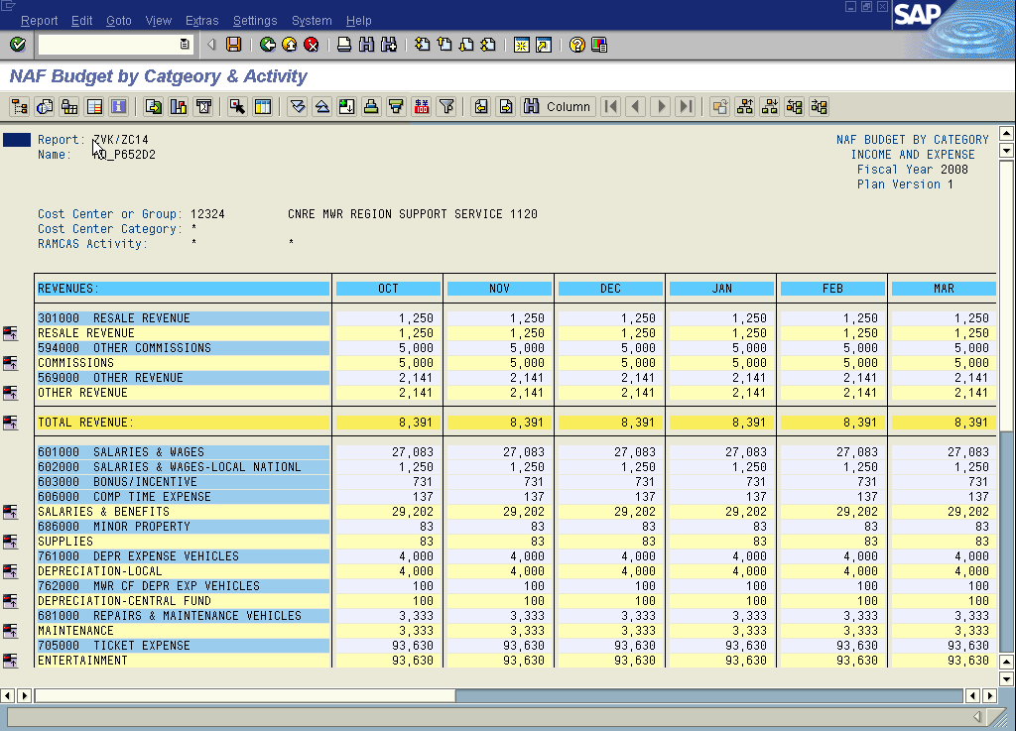

Conversion to Excel

This report can be exported into Excel where it can then be manipulated and be input into the actual NAF Budget Workbook.
After running the report, click on the Options/Office Integration button.

Be sure to click the radio button for Microsoft Excel in the Office Integration section. Then hit the green check mark.

Be aware that the Excel version is Protected. This means that you will not be able to do anything to the file, ie., change column or row widths, insert or type over data or formulas, etc. There are two ways to unprotect the file: 1) you can de-select the Worksheet Protection when converting to Excel or 2) Once in Excel, go to Tools → Protections → Unprotect Sheet. Also be aware that the sum amounts (in rows or columns) do not contain a formula so changing the data will not change the total without inserting a formula.

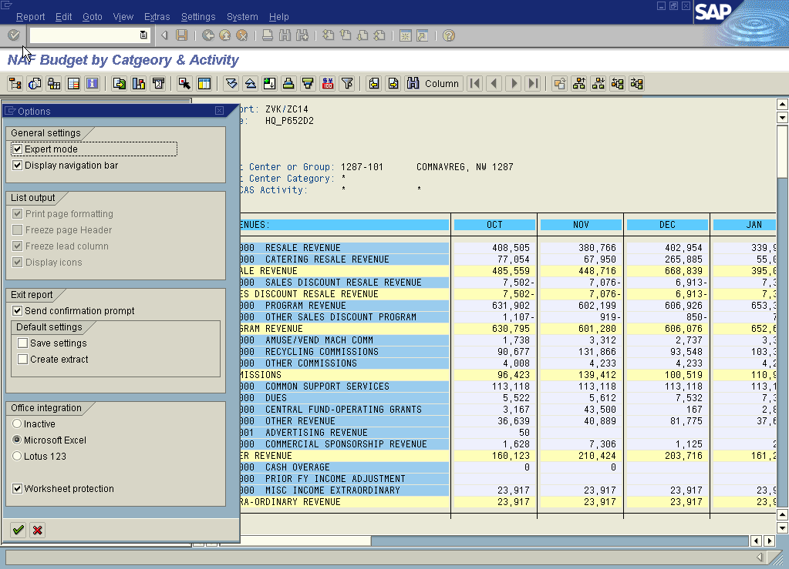
Select Microsoft Excel

Decide whether or not you want the file protected

Some users may experience an Excel pop-up window asking them to “Enable Macros”. Here you will need to respond with a Yes otherwise the spreadsheet will come up blank.

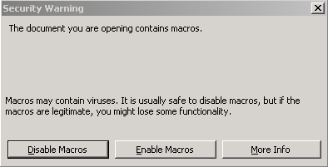

WARNING: When you select this integration you will automatically display every report in the excel format. To undo, you will need to go back into the Options/Office Integration and select Inactive under Office Integration. Then hit the green check mark.

The excel version looks as follows:

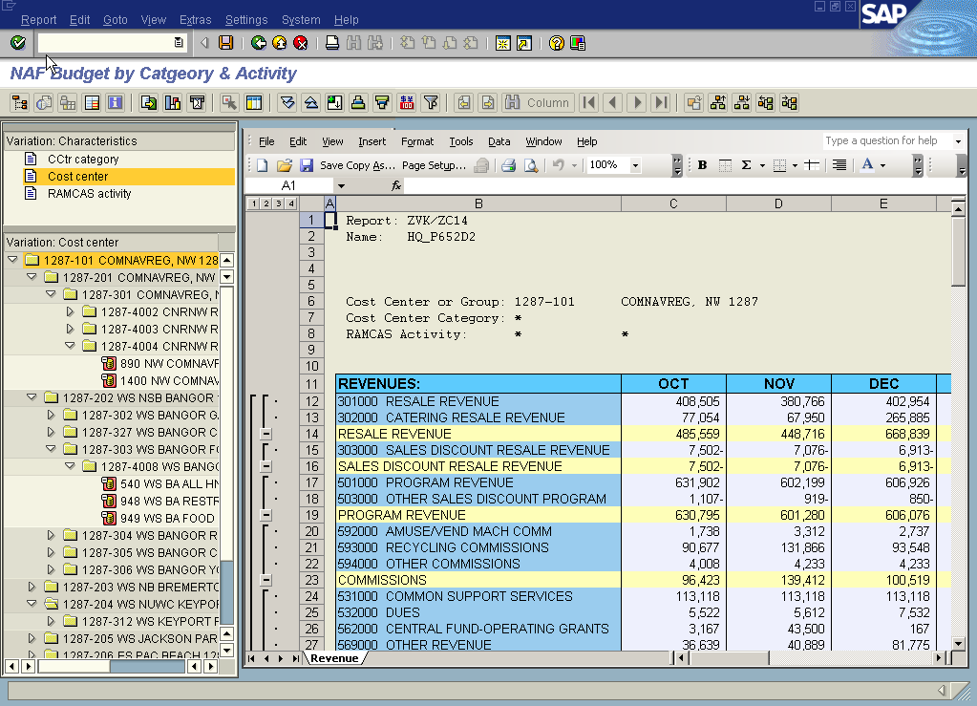
To print this report, use the SAP Print icon
To Save as an Excel file, use the Excel commands

Be aware that even though all data appears as positive values, the Revenue numbers are actually negatives. You will need to correct this if you plan on copying these cells directly into the NAF Budget standard Excel worksheets.

Once open, you can then save this file as a ‘filename’ for future reference. To save you must use the Excel commands, not the SAP commands. This filename should be something that identifies the activity and/or cost center and the version. Also, you may want to establish a specific folder for these files so that they can be readily accessed.

You can save each individual activity, each individual Category or the entire fund.

WARNING: Once you have converted the file to Excel, there is no longer a link with SAP so any changes made in the Excel version will not show up in SAP.

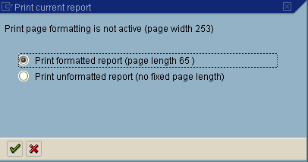
To print this report, be sure to use the SAP printer icon on the top toolbar, not the printer icon on the Excel worksheet. SAP will give you the following window:
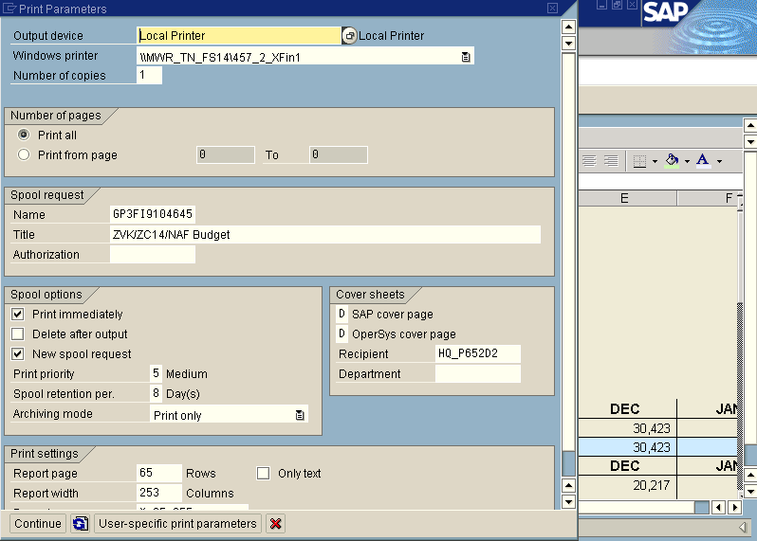
Leave it as is and click the green check mark and continue with the SAP printing function.
Check the printer settings
Click here to finish the printing
Note: If the Excel version comes up and it is a blank file then you will need to reset the Macro Security level to Medium. To do this, open Excel, Select Tools, then Options. Now select Security, Macro Security and change it from Very High or High to Medium.

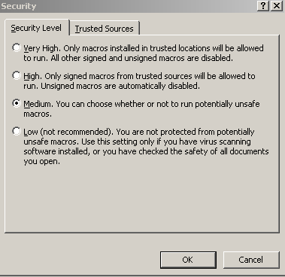

CONTACTS
& TIPS

CNIC Contact Information

Kath Wade, Head NAF Financial Analysis (N948D)
Comm: 901-874-6614
DSN: 882-6614
E-Mail: Kathy.Wade1@navy.mil

Steve Williams, NAF Financial Analyst (N948D2)
Comm: 901-874-6594
DSN: 882-6594
E-Mail: Steve.Williams5@navy.mil

Meredith Wilson, NAF Financial Analyst (N948D1)
Comm: 901-874-6598
DSN: 882-6598
E-Mail: Meredith.Wilson@navy.mil

Ada Edwards, Admin Assistant (N948S)
Comm: 901-874-6592
DSN: 882-6592
E-Mail: Ada.Edwards@navy.mil

Changing Excel Macro Security

If the Excel version comes up and it is a blank file then you will need to reset the Macro Security level to Medium. To do this, open Excel, Select Tools, then Options. Now select the Security tab, Macro Security button at bottom and change it from Very High or High to Medium.

Cost Centers/Cost Center Groups

A Cost Centers is a single number that falls in the range 1 – 20000. Cost Centers do not include commas. Ex. 519 or 10305

A Cost Center Group consist of the Company Code (a four digit number that resembles the old RAMCAS Fund number) followed by a hyphen and then another four digit number beginning with either a 4, 5 or 6. Ex. 1120-4008 or 1199-5136.

Cost Center Groups
Cost Centers

Adding Transactions Codes to Favorites

To add a transaction code to your SAP Favorites simply select Favorites from the
main menu and pick Insert transaction and type in KP06 or KSBB and then click the
green check mark.

